4GB Spy Pens

User Manual

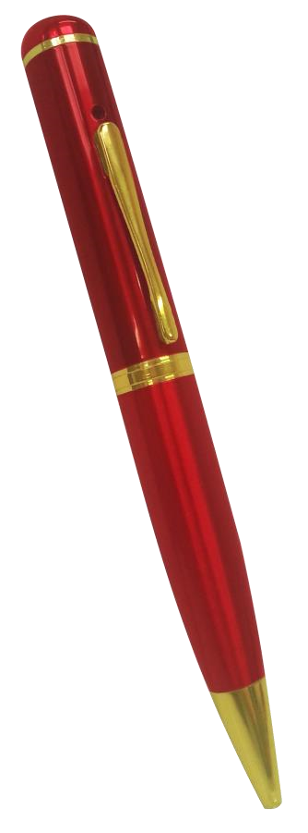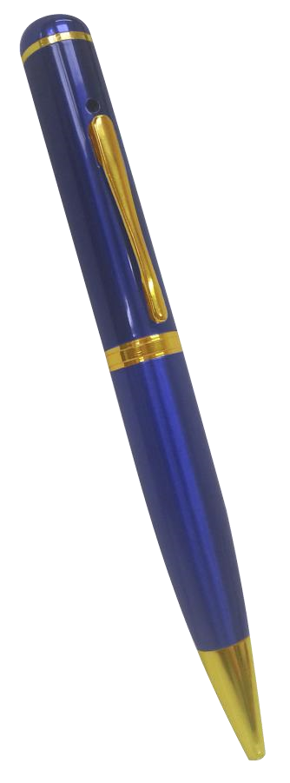

Contents
Package Contents 1
Before You Start 2
Overview 2
Controls 2
USB: Syncing and Charging 2
Microphone 2
Power/Control 2
Recording Switch 3
How to Record 3
Camera Mode 3
Video Mode 3
Timestamp Edit 3

Package Contents
- 4GB Spy Pen
- USB Cable
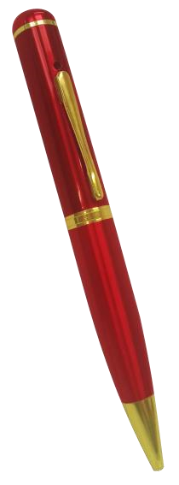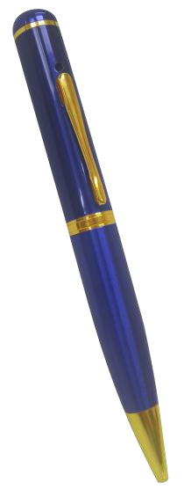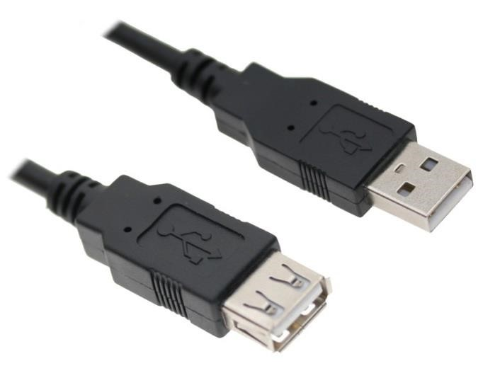

or

Before You Start
Make sure you have charged the device for 8 or more hours prior to full use.
It is recommended that you charge for 24 hours; however we know this is not always possible.
Turn over for charging instructions…

Overview

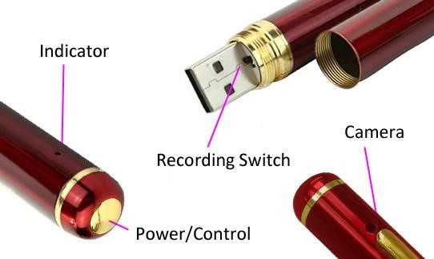

Figure 1
Figure 1 shows the controls that the pen uses. Nothing appears out of the ordinary, it looks and works just like a standard pen. However it is packed full of useful features which enable anyone to monitor and record events.

Controls

USB: Syncing and Charging
To access the USB unscrew the two halves of the pen, you are now able to insert the pen into the USB slot on your computer or into the cable that is supplied with the pen; this charges the internal battery and enables you to transfer the files that are saved on the pens memory.

Microphone
The microphone works just like any other; it will capture the sound for the videos and audio recorder.

Power/Control
This button enables you to switch the pen on, this will either go into video or picture mode depending on what you have set the recording switch to (explained below).

Recording Switch
With the pen facing you as shown in figure 1, if the switch it set to the left then the pen is in video mode. If the switch is set to the right then the pen is in camera mode.

How to Record

Camera Mode
First, make sure the mode switch is set to the ‘camera’ position.
Press and hold the Power/Control button until you can see the indicator has turned amber (this should only take 2 or 3 seconds). When the pen is ready to take photos this indicator will turn blue. Once the indicator has turned blue then all you need to do is point the pen in the direction you wish to take a picture of and quickly press the Power/Control button. The indicator will flash amber whilst the picture is taking and then turn blue again when ready to take the next one.
When you are done taking pictures press and hold the Power/Control button until you can see the indicator go out (this should only take 2 or 3 seconds). After the indicator has gone out the camera is now off.

Video Mode
First, make sure the mode switch is set to the ‘camera’ position.
Press and hold the Power/Control button until you can see the indicator has turned amber (this should only take 2 or 3 seconds). The pen will automatically start recording video and the indicator will light up blue. Once the indicator has turned blue then all you need to do is point the pen in the direction you wish to record and leave it be. To stop the pen recording video, quickly press the
Power/Control button and the indicator will turn amber; this means that it is not recording anything. To start recording video again quickly press the Power/Control button and the indicator will turn blue and start recording video.
When you are done taking videos press and hold the Power/Control button until you can see the indicator go out (this should only take 2 or 3 seconds). After the indicator has gone out the camera is now off.

